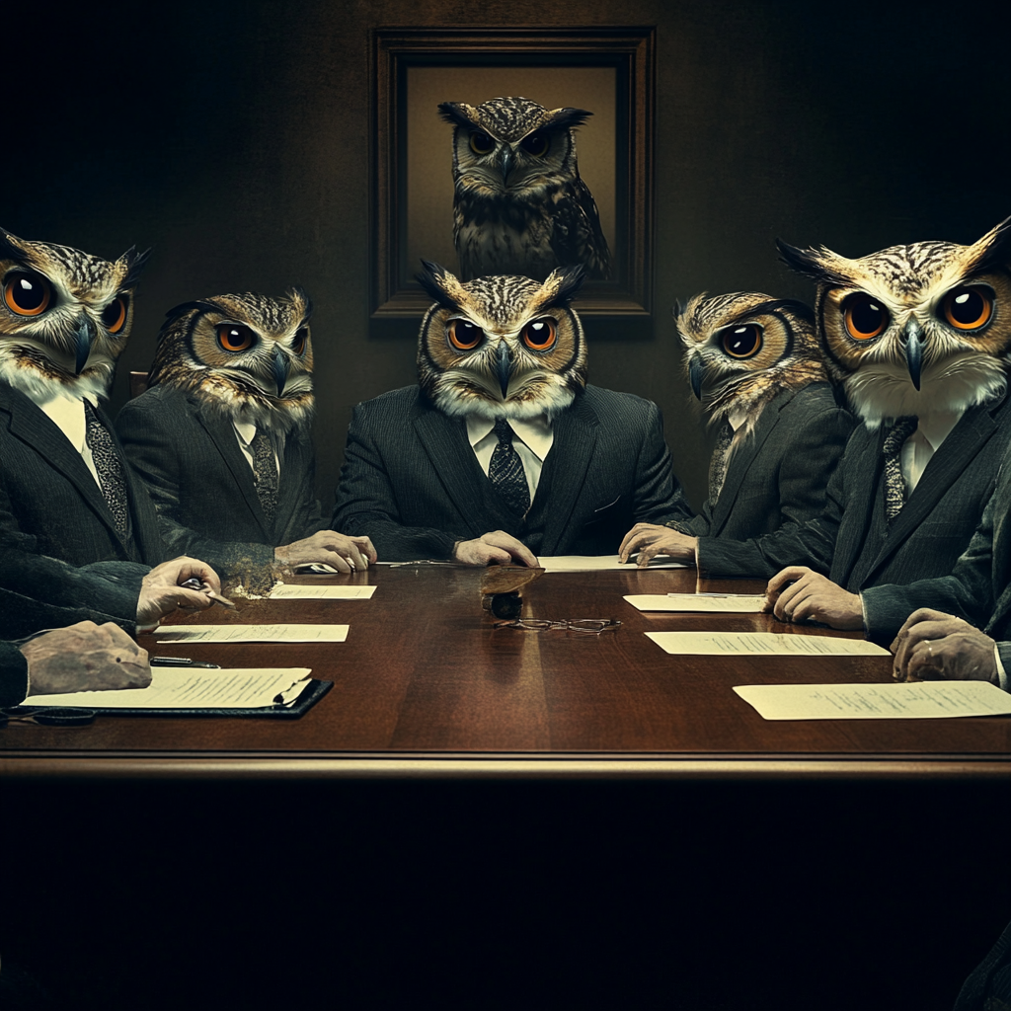

**Title CSI Short Story Template**

Cover Subtitle here for this short story/novella template

This is story book that can fit in your pocket – whether printed out (if you have big pockets!) or available on your smartphone.

It’s a low-cost and low profile knowledge repository.

Margins:

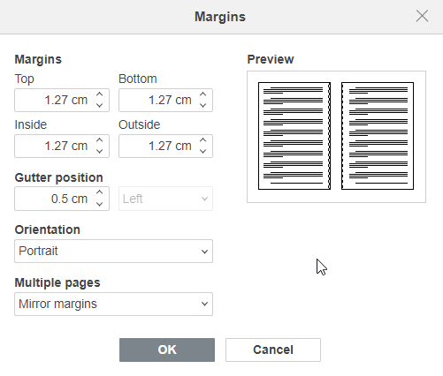

TABLE OF CONTENTS

Heading 1 - Tools 3

Heading 2 3

Heading 3 3

Shadows in Orbit 4

NOVELLA IDEA 5

PROTAGONIST 5

MJ Prompt: 5

CENTRAL CONFLICT 5

TWIST 6

CLIMAX 6

FINAL TWIST 6

THEMES: 7

NOVELLA STRUCTURE 7

### **MAIN CHARACTER:** 7

## **ACT I: THE SETUP (CHAPTERS 1-3)** 8

### **CHAPTER 1: THE INFILTRATION** 8

### **CHAPTER 2: SIGNS OF SABOTAGE** 8

### **CHAPTER 3: THE FIRST ATTACK** 9

## **ACT II: RISING STAKES (CHAPTERS 4-7)** 9

### **CHAPTER 4: A DEADLY GAME OF DECEPTION** 9

### **CHAPTER 5: A FRACTURED CREW** 10

### **CHAPTER 6: THE BLACK NEBULA’S TRUE MOTIVE** 10

### **CHAPTER 7: THE CREW UNITES** 11

## **ACT III: THE CLIMAX AND RESOLUTION (CHAPTERS 8-10)** 12

### **CHAPTER 8: THE BATTLE FOR CONTROL** 12

### **CHAPTER 9: THE ULTIMATE SACRIFICE** 12

### **CHAPTER 10: A NEW BEGINNING** 13

### **THEMES:** 13

- **Redemption and Sacrifice:** 13

- **Trust and Betrayal:** 13

- **The Value of Human Connection:** 14

- **Intellectual Property and Power:** 14

# Heading 1 - Tools

This is the 6 x 9 Basic Template. Paste your manuscript into this template or simply start typing. Delete this text prior to use.

## Heading 2

This is testing the Normal paragraph setting after pressing Enter from Heading 2.

Here’s the example code text:

Source Text (Lucida Console 10)

***Note (Bookerly 11)***

### Heading 3

#### Heading 4

Shadows in Orbit

This is a test topic/section separator, similar to what’s used in the Red and Blue Team Field Manuals

This Topic Header style is set to be included in the Table of Contents

# NOVELLA IDEA

In the near future, space exploration has become commercialized. Corporations dominate the stars, and space stations serve as hubs for mining, research, and covert operations. Intellectual property (IP) is a precious currency, with rival corporations hiring private operatives to protect or steal it.

# PROTAGONIST

**Drake Allard** is a master manipulator, working as a PR strategist for Helion Technologies, a major space research firm. He thrives on psychological warfare, adept at turning the tide of public opinion by fabricating scandals, leaking false information, and using people as pawns in his corporate game. He views people as tools to be used, with no qualms about destroying reputations if it serves his goals.



## MJ Prompt:

Imagine Male master manipulator, dressed in business suit, cartoon style

# CENTRAL CONFLICT

Drake is hired by Helion Technologies to destroy the reputation of **Isaac Vega**, a former undercover agent turned whistleblower. Isaac had recently exposed classified operations where Helion exploited smaller colonies and stole cutting-edge IP from rival corporations. Helion's legal department can't touch Isaac due to his airtight evidence, so they opt for Drake's expertise to discredit him.

Drake launches a sophisticated smear campaign, creating fake histories, fabricating damning footage, and manipulating the media to frame Isaac as a traitor who sold confidential data to hostile alien factions during his undercover days. The campaign begins to work; Isaac's public image starts to crumble, and even his closest allies start to doubt him.

# TWIST

As Drake digs deeper into Isaac's past to find more material, he discovers that Isaac had not only exposed Helion's crimes but had also been instrumental in protecting several colonies from a deadly experimental technology that Helion had been secretly developing. The tech, which is related to controlling human minds via nanotechnology, was considered too dangerous, but Helion continued to test it in secret.

Drake uncovers documents revealing that his own employer, Helion, has plans to use this technology on the space station's inhabitants to gain control over entire sectors of space. He realizes that in his manipulation of people, he's unknowingly been a cog in a much larger, darker game—a game that threatens the freedom of the entire spacefaring population.

# CLIMAX

Confronted with this truth, Drake is forced to reconsider his beliefs. His ability to manipulate others is now being used against him, and he is faced with an ethical dilemma: does he continue with the smear campaign to secure his career and maintain his comfortable life, or does he expose Helion, risking his life and reputation to save others?

# FINAL TWIST

In a shocking turn, Drake attempts to betray Helion and warn the public about the mind-control technology, but Isaac—who has been watching Drake from the shadows—steps in. Instead of helping, Isaac reveals that he anticipated Drake’s turn and has been playing his own game all along. Isaac uses Drake's own manipulative tactics against him, feeding him false information and making him believe he had found the truth. In reality, Isaac is a far more cunning operator than Drake imagined, and he's using Drake to dismantle Helion in a way that benefits him and his hidden agenda.

In the end, Drake's career is ruined, and he becomes a pawn in the same power plays he once mastered. But the smear campaign against Isaac collapses, and Helion’s true corruption is laid bare—though it's unclear whether Isaac is a hero or a villain himself.

# THEMES:

- The ethics of manipulation and control

- Intellectual property as power in space exploration

- The blurry line between heroes and villains in the battle for truth

- The limits of power when faced with unexpected adversaries

The story challenges the protagonist’s belief in his own superiority, showing how even the most skilled manipulator can fall prey to deeper layers of deception.

# NOVELLA STRUCTURE

**GENRE:** Technothriller

**CHAPTERS:** 10

**STRUCTURE:** Three-act format

## ### **MAIN CHARACTER:**

**Name:** Kal Athen

**Role:** Undercover agent

**Development Arc:** Kal starts as a detached, pragmatic agent who believes the mission always comes first. Over time, he grows emotionally connected to his crew, realizing the importance of loyalty and personal sacrifice. He transitions from being a loner focused on survival to a leader willing to risk everything for others.

---

## ## **ACT I: THE SETUP (CHAPTERS 1-3)**

### ### **CHAPTER 1: THE INFILTRATION**

- **Setting:** A bustling space station orbiting a distant planet.

- **Plot:** Kal, posing as a security consultant for a shipping company, boards the starship **Vanguard** as part of his undercover mission. His objective is to gather intelligence on a growing terrorist faction, **The Black Nebula**, who are suspected of planning a galaxy-wide uprising by hijacking critical spacecraft.

- **Character Development:** Kal is shown as methodical and cold, more focused on the mission than on the people around him. His lack of emotional attachment is evident in his interactions with the crew.

- **Conflict:** Kal receives an encrypted message from his handler, warning him that one of the crew members may be an undercover Black Nebula agent.

### ### **CHAPTER 2: SIGNS OF SABOTAGE**

- **Plot:** As the Vanguard begins its routine space run, small technical issues arise, hinting at sabotage. The crew, unaware of Kal's true identity, start to suspect an inside job. Tensions build as the first hints of a possible takeover surface.

- **Character Development:** Kal investigates the crew, using his undercover identity to blend in and manipulate the investigation without drawing suspicion. He sees his crewmates as mere assets to be used for his mission.

- **Conflict:** The captain, **Cpt. Rhea Andros**, grows suspicious of Kal, while the ship’s engineer, **Niko**, uncovers unusual activity in the ship’s systems.

### ### **CHAPTER 3: THE FIRST ATTACK**

- **Plot:** As they pass near a dense asteroid field, the Vanguard is ambushed by a squad of Black Nebula ships. The ship suffers heavy damage, and the terrorists demand the crew’s surrender.

- **Character Development:** Kal coldly advises the captain to abandon some of the crew to make an escape, shocking them. This moment highlights Kal’s detachment from their humanity, creating tension between him and the rest of the crew.

- **Inciting Incident:** The terrorists board the Vanguard, forcing Kal into action. He must now protect his cover while preventing the terrorists from taking over the ship.

---

## ## **ACT II: RISING STAKES (CHAPTERS 4-7)**

### ### **CHAPTER 4: A DEADLY GAME OF DECEPTION**

#### - **Plot:**

Kal discovers that one of the crew members, **Dr. Mira Valen**, is secretly working for Black Nebula and feeding information to the terrorists. He uses this knowledge to manipulate the terrorists, feeding false intel while planning to neutralize Mira.

#### - **Character Development:**

Kal's manipulative nature shines as he plays both sides against each other, but this distance from others starts to show cracks. He begins to feel a sense of responsibility for the crew’s survival.

- **Conflict:** Kal wrestles with the idea of exposing himself as an undercover agent versus continuing to use manipulation as his primary tool. The crew's growing mistrust complicates his position.

### ### **CHAPTER 5: A FRACTURED CREW**

#### - **Plot:**

The crew's morale is shattered after several failed attempts to regain control of the ship. Meanwhile, Kal discovers that The Black Nebula isn’t just planning to take over the Vanguard, but to use it to launch a galaxy-wide strike by hijacking military-grade starships.

#### - **Character Development:**

Kal begins to empathize with the crew, particularly **Lt. Serena Kane**, a young officer who refuses to give up hope. Her unshakable belief in saving everyone challenges Kal’s cold worldview.

#### - **Turning Point:**

Kal saves Serena’s life during an intense firefight with the terrorists, a moment that causes him to question his detachment and think of the crew as more than expendable.

### ### **CHAPTER 6: THE BLACK NEBULA’S TRUE MOTIVE**

#### - **Plot:**

Kal uncovers a deeper conspiracy—Black Nebula is not just targeting starships but is planning to steal intellectual property from military contractors onboard, aiming to weaponize advanced AI technology for mass control over planetary systems.

#### - **Character Development:**

Kal’s manipulation tactics start to unravel as his emotional investment in the crew deepens. His growing attachment to Serena and others forces him to rethink the "mission first" philosophy.

#### - **Conflict:**

Kal faces pressure from his handler to finish the mission at any cost, even if it means sacrificing the entire crew. This leads to an internal struggle between his loyalty to the mission and his growing connection to the people around him.

### ### **CHAPTER 7: THE CREW UNITES**

- **Plot:** Kal decides to trust the crew and reveals his true identity as an undercover agent. This revelation fractures trust further, but with the terrorists closing in, the crew has no choice but to work with Kal.

- **Character Development:** Kal assumes leadership, guiding the crew through a desperate plan to regain control of the ship. His manipulative skills are now repurposed toward genuine leadership as he uses them to unite the crew.

- **Turning Point:** The crew agrees to fight back against the terrorists, with Kal taking the helm in orchestrating their defense. However, a key betrayal from **Niko** threatens to derail their plans.

---

## ## **ACT III: THE CLIMAX AND RESOLUTION (CHAPTERS 8-10)**

### ### **CHAPTER 8: THE BATTLE FOR CONTROL**

#### - **Plot:**

A full-scale battle breaks out aboard the Vanguard. Kal leads the crew in a coordinated strike against the terrorists, using the ship’s AI system to outmaneuver the enemy. However, Black Nebula’s leader, **Commander Voren**, boards the ship with elite forces.

- **Character Development:** Kal, now fully committed to saving the crew, puts himself in danger multiple times, showing how far he’s come from his original detachment. His relationship with Serena strengthens as they fight side by side.

- **Conflict:** As they approach victory, Kal is cornered by Voren, who reveals that Kal’s handler has been working with Black Nebula all along. This betrayal shakes Kal’s belief in the system he once served.

### ### **CHAPTER 9: THE ULTIMATE SACRIFICE**

- **Plot:** With the crew outnumbered, Kal hatches a final plan to disable the ship’s core and prevent Black Nebula from escaping with the AI technology. This requires him to risk his life in a high-stakes maneuver.

- **Character Development:** Kal makes peace with his past mistakes and accepts that he must sacrifice himself to ensure the survival of the crew. His transformation from cold manipulator to selfless leader is complete.

- **Climax:** Kal successfully disables the core, preventing Black Nebula’s escape. However, the ship’s systems go into meltdown, forcing the crew to evacuate.

### ### **CHAPTER 10: A NEW BEGINNING**

- **Plot:** The crew narrowly escapes the ship as it’s destroyed, but Kal is left behind, presumed dead. In the aftermath, Serena takes over as captain, leading the surviving crew members to safety.

- **Character Development:** In a final twist, Kal is revealed to have survived the explosion but is now operating in the shadows, having abandoned his former life as a government agent. He watches over the crew from afar, content in his new role as protector.

- **Resolution:** Kal’s journey from a manipulative agent to a selfless leader comes full circle. The crew’s survival represents his growth, and the destruction of Black Nebula ensures peace—at least for now.

---

## ### **THEMES:**

### - **Redemption and Sacrifice:**

Kal’s journey is one of personal redemption as he moves from self-interest to self-sacrifice.

### - **Trust and Betrayal:**

The story explores the fragility of trust, both in personal relationships and in institutions.

### - **The Value of Human Connection:**

The novella highlights how even the most hardened individual can change through meaningful human connections.

### - **Intellectual Property and Power:**

The AI technology represents the novel's commentary on how IP can be weaponized for control in a futuristic space setting.

